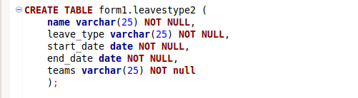

CREATE DATABASE form;

CREATE SCHEMA form1;

NOW CREATE TABLE (ABOVE COMMAND)

SELECT \* FROM form1.leavestype2;